# Part 1

## Task 1.1 Character encodings

## My name is “Nabil Mahmud Islam”. The first three letters of my last name are ‘I’,’s’,’l’. I am preparing the table below according to this.

|  |  |  |  |  |
| --- | --- | --- | --- | --- |
| Character | Hex | Decimal | 7-bit Binary | Octal |
| I | 21 | 33 | 0100001 | 41 |
| s | 53 | 83 | 1010011 | 123 |
| l | 5f | 95 | 1011111 | 137 |

Here we mapped the appropriate Hex value at first then converted it to another equivalent system using the proper method

Hex to Decimal

Multiply each digit by its corresponding power of 16 and add them up.

Hex to 7-bit binary:

Convert the hex number to binary and then pad it with leading zeros if necessary to get a total of 7 binary digits.

Binary to Octal

Group the binary digits into groups of three, starting from the right. Then we convert each group of three binary digits to its corresponding octal digit.

## Task 1.2 Upper Case to lower case to upper case

### 1.2.1

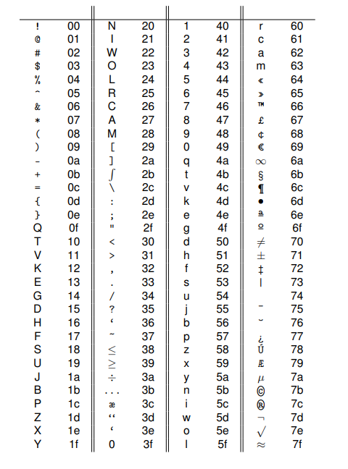

The table above shows that the first upper case letter is **Q** holding the Hex value **(0f).** The first small case letter is **q** having the Hex value **(4a)  
  
(4a- 0f) = 3b**

**(3b)16= (0011 1011)2**

Now, we can convert from upper case to lower case by adding (3b)16 or (0011 1011)2 with each upper case letter’s associated Hex Or 8-bit Binary value to get the lower case.  
  
On the other hand, we can convert from lower case to upper case by subtracting (3b)16 or (0011 1011)2 from each lower case letter’s associated Hex Or 8-bit Binary value to get the upper case.

### 1.2.2

The first character of my last name = ‘I’

The second character of my last name = ’s’

**For an upper-case to lower case**Given,

Character = ‘I’

Equivalent Hex = 21

Equivalent binary = 00100001  
  
Now, for the given character encoding table we have to add **(0011 1011)2** with the binary value to convert the uppercase to lowercase according to our finding in **1.2.1**

|  |  |
| --- | --- |
| Uppercase character’s binary | **0010 0001** |
| Binary needs to be added | **0011 1011** |
| Binary of Lowercase character | **0101 1100** |
|  |  |

Hex of (**0101 1100**) is (5C) .  
  
The associate character according to the character encoding table   
(5C) = i

**For a lower-case to upper case**

Given,

Character = ‘s’

Equivalent Hex = 53

Equivalent binary = 01010011  
  
Now, for the given character encoding table. we have to subtract **(0011 1011)2** from the binary value to convert the lowercase to uppercase according to our finding in **1.2.1**

|  |  |
| --- | --- |
| Binary needs to be subtracted, a= | **0011 1011** |
| 1’s complement of a = | **1100 0100** |
| Add 1 | **0000 0001** |
| 2’s Complement of a = | **1100 0101** |
|  |  |
|  |  |
| Add Lowercase character’s binary | 0101 0011 |
| 2’s Complement of a | **1100 0101** |
| Binary of Upper case character | **0001 1000** |

The result of the above operation is (**0001 1000**) Since we are using 2's complement method, we need to check if the result is negative by looking at the leftmost bit (the sign bit). If the leftmost bit is 1, then the result is negative. In this case, the leftmost bit of () is 0, so the result is positive  
  
Hex of (**0001 1000**) is (18).  
  
The associate character according to the character encoding table   
(18) = S  
  
So both the conversions are correct and done using 2’s complement  
  
  
**Brief Explanation about 2’s complement**Suppose if A-B is needed the equation can be rearranged as A+(-B).  
  
So firstly we convert the second value to their equivalent negative value by doing 1’s complement (changing 1s to 0s and vice versa) then add 1 to the result.   
  
Then we perform simple binary addition to get the result.

# Part 2

|  |  |  |  |  |  |
| --- | --- | --- | --- | --- | --- |
| X1 | X2 | X3 | X4 | Z1 | Z2 |
| 0 | 0 | 0 | 0 | 0 | 1 |
| 0 | 0 | 0 | 1 | 1 | 0 |
| 0 | 0 | 1 | 0 | 1 | 0 |
| 0 | 0 | 1 | 1 | 0 | 1 |
| 0 | 1 | 0 | 0 | 1 | 1 |
| 0 | 1 | 0 | 1 | 1 | 1 |
| 0 | 1 | 1 | 0 | 0 | 1 |
| 0 | 1 | 1 | 1 | 1 | 0 |
| 1 | 0 | 0 | 0 | 0 | 1 |
| 1 | 0 | 0 | 1 | 1 | 0 |
| 1 | 0 | 1 | 0 | 1 | 1 |
| 1 | 0 | 1 | 1 | 0 | 0 |
| 1 | 1 | 0 | 0 | 1 | 1 |
| 1 | 1 | 0 | 1 | 0 | 0 |
| 1 | 1 | 1 | 0 | 1 | 1 |
| 1 | 1 | 1 | 1 | 1 | 0 |

## Task 2.1 Boolean Algebra Expression

**The explanation for SOP:**

There are 4 variables as input in each row which are X1, X2, X3, and X4. Now in each variable, there can be two values which are 0,1. Now if we take the row before last row of the truth table as an example we can see that

|  |  |  |  |
| --- | --- | --- | --- |
| X1 = 1 | X2= 1 | X3 = 1 | X4 = 0 |

As SOP(Sum of products) is written in minterms we can represent the whole row as

In such a way, once we get the value of all the rows then we can sum all of them to get the larger term. So summing all the values in such a way of rows where Z1 = 1 we can get the equation for Z1 and in the same way we can get the value for Z2.  
  
Here we are only taking account of the rows where Z1 = 1 for the equation of Z1 because SOP is represented in minterms. The same goes for getting the equation of Z2.

Z1 =

Z2 =

**The explanation for POS:**

There are 4 variables as input in each row which are X1, X2, X3, and X4. Now in each variable, there can be two values which are 0,1. Now if we take the last row of the truth table as an example we can see that

|  |  |  |  |
| --- | --- | --- | --- |
| X1 = 1 | X2= 1 | X3 = 1 | X4 = 1 |

As POS(Product of Sum) is written in max terms we can represent the whole row as

In such a way, once we get the value of all the rows then we can multiply all of them to get the larger term. So multiplying all the values in such a way of rows where Z1 = 0 we can get the equation for Z1 and in the same way we can get the value for Z2.  
  
Here we are only taking account of the rows where Z1 = 0 for the equation of Z1 because POS is represented in maxterms. Same goes for getting the equation of Z2.

Z1=

Z2 =

## Task 2.3: Optimised circuit

The karnaugh maps are given below for each output

Steps 1,2 are attached as screenshots from Google slides and then step 3 is derived as equation

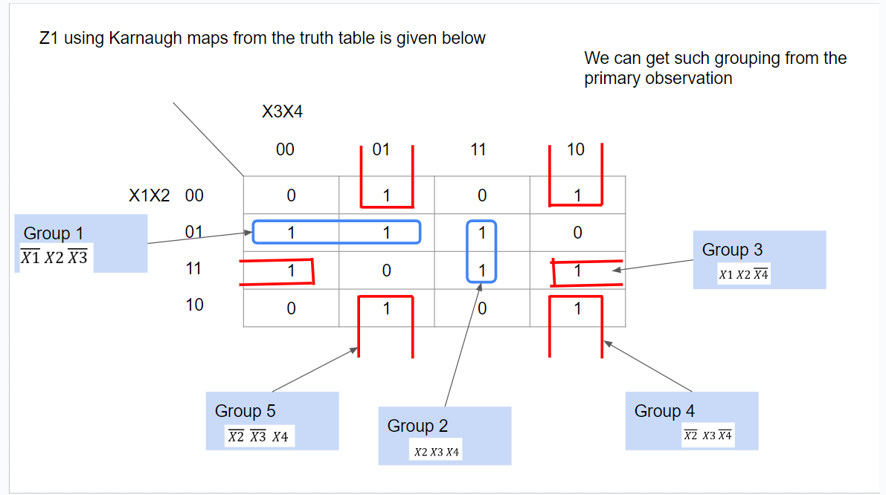

Z1=

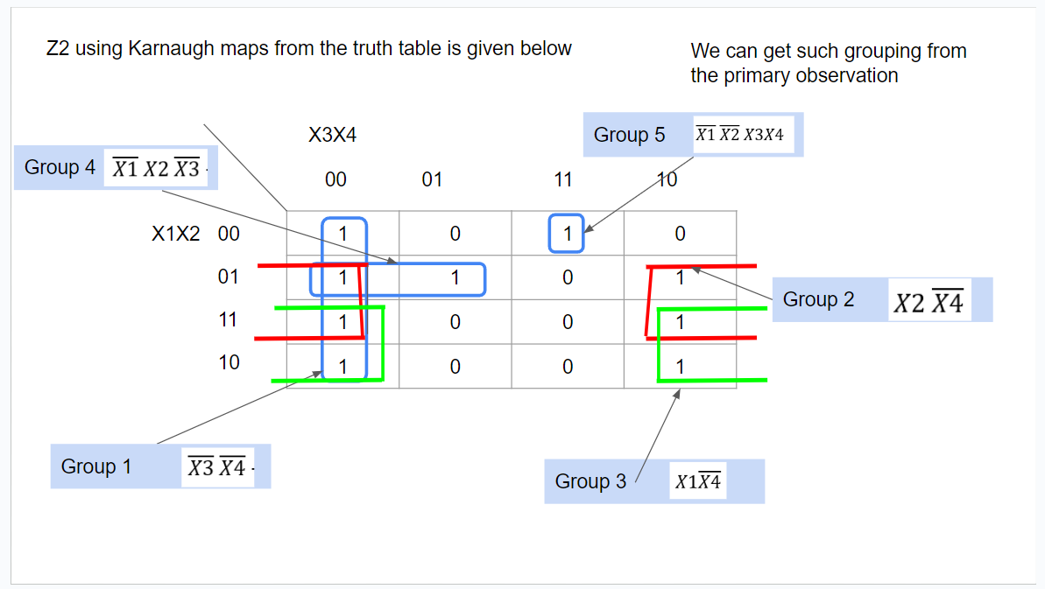

Z2 =

So finally we can conclude that   
Z1=   
Z2 =   
  
Which are more optimized from the equation we found in task 2.1 . As a result we will get a better circuit which will be more cost efficient to implement.